# 

**PROJECT** **REPORT**

**ON**

**BOOK MANAGEMENT SYSTEM USING FLASK**

**SUBMITTED**

**TO**

**DEPARTMENT OF COMPUTER SCIENCE**

**UNDER THE SUPERVISION OF**

**Ms. Khushboo Gill**

|  |  |
| --- | --- |
|  | **Submitted By:** |
|  | **Name(s):Ishan** |
|  | **Roll No. 1510991273** |
|  | **Rahul Passi** |
|  | **Roll No. 1510991496**  **Ravjot Singh** |
|  | **Roll. No. 1510991513**  **Ritesh Kamra**  **Roll. No. 1510991529** |

**Semester: 7th**

**Session: July’18-Dec’18**

**CHITKARA UNIVERSITY**

**CHANDIARH-PATIALA NATIONAL HIGHWAY**

**RAJPURA, DISTT PATIALA**

**PUNJAB, INDIA**

**DECLARATION**

We hereby declare that the Project work titled “**Book Management System Using Flask**” submitted as part of Bachelor’s degree in Computer Science, at Chitkara University, Punjab is an authentic record of our own work carried out under the supervision of Ms. Khusboo Gill.

**Place: Rajpura Verified By:**

|  |
| --- |
| **Name(s):Ishan** |
| **Roll No. 1510991273 Signature of Supervisor** |
| **Rahul Passi** |
| **Roll No. 1510991496**  **Ravjot Singh**  **Roll No. 1510991513**  **Ritesh Kamra** |
| **Roll. No. 1510991529** |

**ACKNOWLEDGEMENT**

It is our pleasure to be indebted to various people, who directly or indirectly contributed in the development of this work and who influenced my thinking, behavior and acts during the course of study.

We express our sincere gratitude to all for providing us an opportunity to undergo Major Project as the part of the curriculum.

We are thankful to **“Ms. Khushboo Gill”** for her support, cooperation, and motivation provided to us during the training for constant inspiration, presence and blessings.

We also extend our sincere appreciation to **“Ms. Khushboo Gill’’** who provided her valuable suggestions and precious time in accomplishing our major project.

Lastly, we would like to thank the almighty and our parents for their moral support and friends with whom we shared our day-to-day experience and received lots of suggestions that improve our quality of work.

**CONTENTS**

**Title Page No.**

Declaration 2

Acknowledgement 3

1. **Introduction** 5
2. **Background**  6
3. **Overview** 7
4. **Requirements to run the application** 8
   1. Python 2.7 8
   2. Flask 8
   3. SQLite 9
5. **Literature Review** 10
6. **Work Done** 11
7. **Conclusion** 16
8. **Future Scope** 17
9. **References** 18

**INTRODUCTION**

Our modern lifestyle has incorporated some new changes to improve our day to day lives and hence save time and money which feels like a necessity and an option at the same time. People want free things and enjoy them to their maximum potential. That is why our project exists, to bring happiness and convenience to the people who love to read by giving them the option to read books in digital format for free as well as giving them an option to add their digital collection as well for all to enjoy.

What our team proposes here, is that a person can access the website and read several of the books our collection has to offer in various genres and also allowing them to be part of our community to add some books which they want to share to the other readers. And in order to reduce the negative effects of the toxic part of the community, there is no option to remove them. That authority would lie with the admin, which would be our team, and the one who uploaded the book. Ensuring that no content would be removed unless there is a major problem or the uploader feels so.

**BACKGROUND**

In the modern fast-paced lives of the human race, we usually forget to take a break and relax our bodies as well as our minds. In the past, people mostly used to read books and share them in the Library but as we all know, those places are a thing of the past for our new generation of young people and the ones who used to visit them are unable to find the time to go there and those who manage to visit the Libraries are fed-up with the time which is limited for them to keep the possession of a book and unable to either issue or carry many of them, not to mention the transportation costs and the monthly charges they have to pay for their membership in the Libraries.

Also, the condition of the books kept in the libraries are always deteriorating since they are made of paper which is decomposable and with time decay in both color and thickness which could result in the pages easily being torn or hard to understand with the faded words which would make any person fell as a waste of their time and resources.

Since, the restoration process of a book is long as well as expensive and harmful to the nature, resulting in the cutting of trees as well as the printing costs in the printing press and the new, modified bindings, our project enables us to reduce to reduce the wastage of paper, money and time of the people and help them with a shared and comfortable experience.

This project also looks at the problems and errors related to the current system of libraries:

* Unable to carry the heavy weight of the detailed books.
* Unable to issue multiple books.
* Constant need to travel to reach the Library.
* The deteriorating states of the old books.
* Membership fee for a rarely used service.
* Inability to find the required book with ease.
* Lacking collections of Modern-Day Literature, for example- Manga.

Hence, to address these issues faced by those who love reading, our team came up with the idea to create a **“Book Management Web Application”** designed to quench the thirst for the new as well as old readers who love reading but hate the Libraries and the problems that come with them.

Its main purpose is to deliver a collection of books of various types with no limitation and granting access to the user who uploads a certain piece of literature and gaining recognition with it with the assurance that their content will not be tampered with.

**Overview**

Book Management Web Application as the name suggests is as website to help people finding and reading new or old books to their liking as well as adding some of their own private collection which they wish to share. This will be useful to those people who keep a digital copy of their books and like a free-to-use service platform and the option to view books categorized in various genres.

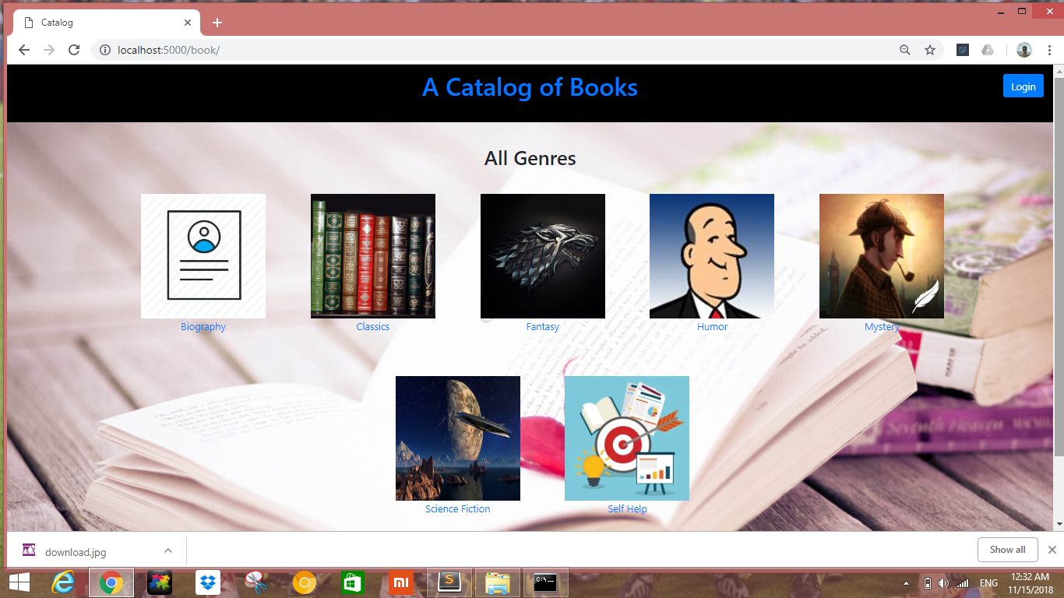

**REQUIREMENTS TO RUN THE APPLICATION**

**PYTHON 2.7:**

Python is an interpreted high-level programming language for general-purpose programming. Created by Guido van Rossum and first released in 1991, Python has a design philosophy that emphasizes code readability, notably using significant whitespace. It provides constructs that enable clear programming on both small and large scales. In July 2018, Van Rossum stepped down as the leader in the language community.

Python features a dynamic type system and automatic memory management. It supports multiple programming paradigms, including object-oriented, imperative, functional and procedural, and has a large and comprehensive standard library.

**Features:**

* Presence of Third Party Modules.
* Extensive Support Libraries.
* Open Source and Community Development.
* Learning Ease and Support Available.
* User-friendly Data Structures.
* Productivity and Speed.

**FLASK:**

Flask is a micro web framework written in Python. It is classified as a microframework because it does not require particular tools or libraries. It has no database abstraction layer, form validation, or any other components where pre-existing third-party libraries provide common functions. However, Flask supports extensions that can add application features as if they were implemented in Flask itself. Extensions exist for object-relational mappers, form validation, upload handling, various open authentication technologies and several common framework related tools. Extensions are updated far more regularly than the core Flask program. Flask is commonly used with MongoDB, which gives it more control over databases and history.

**Features:**

* Contains development server and debugger
* Integrated support for unit testing
* RESTful request dispatching
* Uses Jinja2 templating
* Support for secure cookies (client side sessions)
* 100% WSGI 1.0 compliant
* Unicode-based
* Extensive documentation
* Google App Engine compatibility
* Extensions available to enhance features desired.

**SQLite:**

SQLite is a relational database management system contained in a C programming library. In contrast to many other database management systems, SQLite is not a client–server database engine. Rather, it is embedded into the end program.

SQLite is ACID-compliant and implements most of the SQL standard, using a dynamically and weakly typed SQL syntax that does not guarantee the domain integrity.[

SQLite is a popular choice as embedded database software for local/client storage in application software such as web browsers. It is arguably the most widely deployed database engine, as it is used today by several widespread browsers, operating systems, and embedded systems (such as mobile phones), among others. SQLite has bindings to many programming languages.

**LITERATURE REVIEW**

In the modern fast-paced lives of the human race, we usually forget to take a break and relax our bodies as well as our minds. In the past, people mostly used to read books and share them in the Library but as we all know, those places are a thing of the past for our new generation of young people and the ones who used to visit them are unable to find the time to go there and those who manage to visit the Libraries are fed-up with the time which is limited for them to keep the possession of a book and unable to either issue or carry many of them, not to mention the transportation costs and the monthly charges they have to pay for their membership in the Libraries.

Also, the condition of the books kept in the libraries are always deteriorating since they are made of paper which is decomposable and with time decay in both color and thickness which could result in the pages easily being torn or hard to understand with the faded words which would make any person fell as a waste of their time and resources.

Since, the restoration process of a book is long as well as expensive and harmful to the nature, resulting in the cutting of trees as well as the printing costs in the printing press and the new, modified bindings, our project enables us to reduce to reduce the wastage of paper, money and time of the people and help them with a shared and comfortable experience.

This project also looks at the problems and errors related to the current system of libraries:

* Unable to carry the heavy weight of the detailed books.
* Unable to issue multiple books.
* Constant need to travel to reach the Library.
* The deteriorating states of the old books.
* Membership fee for a rarely used service.
* Inability to find the required book with ease.
* Lacking collections of Modern-Day Literature, for example- Manga.

Hence, to address these issues faced by those who love reading, our team came up with the idea to create a **“Book Management Web Application”** designed to quench the thirst for the new as well as old readers who love reading but hate the Libraries and the problems that come with them.

Its main purpose is to deliver a collection of books of various types with no limitation and granting access to the user who uploads a certain piece of literature and gaining recognition with it with the assurance that their content will not be tampered with.

**Work Done:**

**Home Page:-**



This is the default home page, which will be displayed when you type localhost:5000 in your browser ( checked in both Google Chrome and Mozilla Firefox ).

The page includes a login button which uses Gmail login and all seven genres are displayed i.e. Biography, Classics, Fantasy, Humor, Mystery, Science Fiction, Self-Help.

Clicking on them will display the books of that particular genre.

A normal user without any login can view all the e-books but can’t edit their information.

**Sample book:**

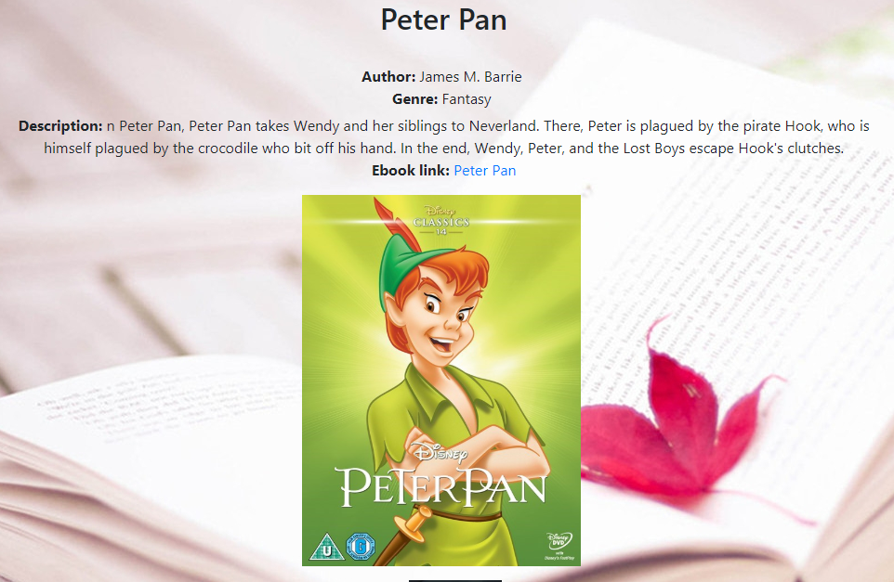

There are some books created already (by admin) which no one can edit or delete. This is done to prevent someone from deleting all the books.

**Logging in:**

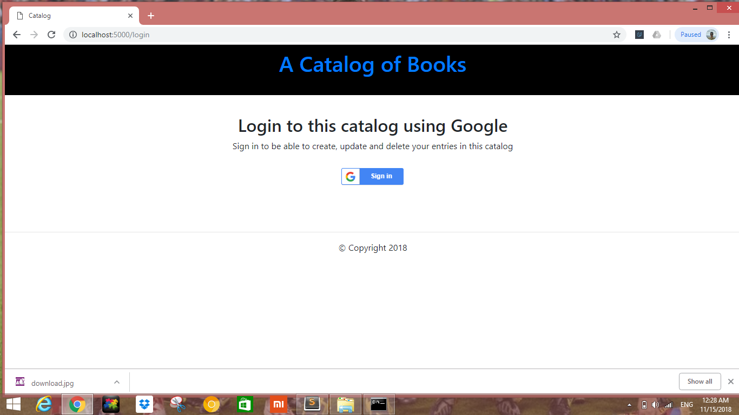

**After successful login:**

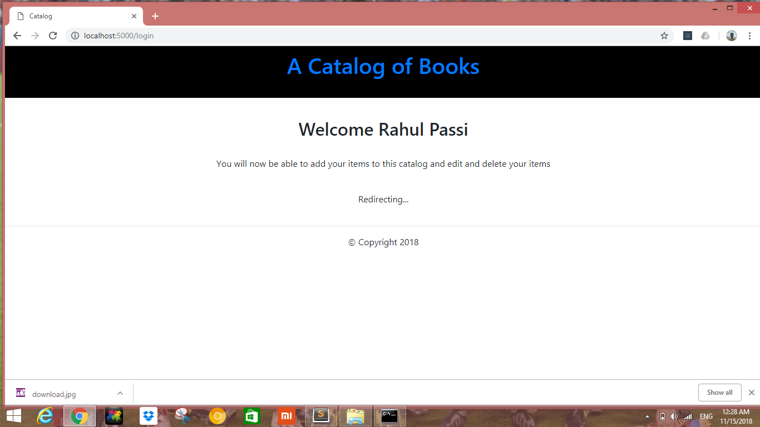

**Home page after logging in:**

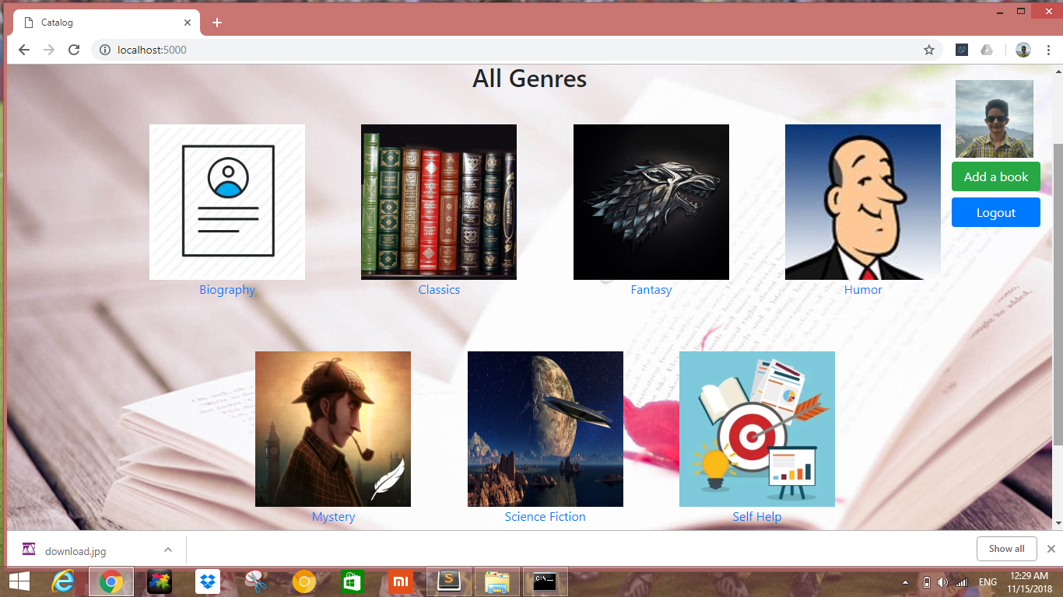

Now, as your login is successful, you can edit, delete your books or create new books.

This is because you are now an authorized user and you have permission to perform CRUD operations on your own books.

Clicking on books that you created will give you option to edit or delete them.

**For example:**

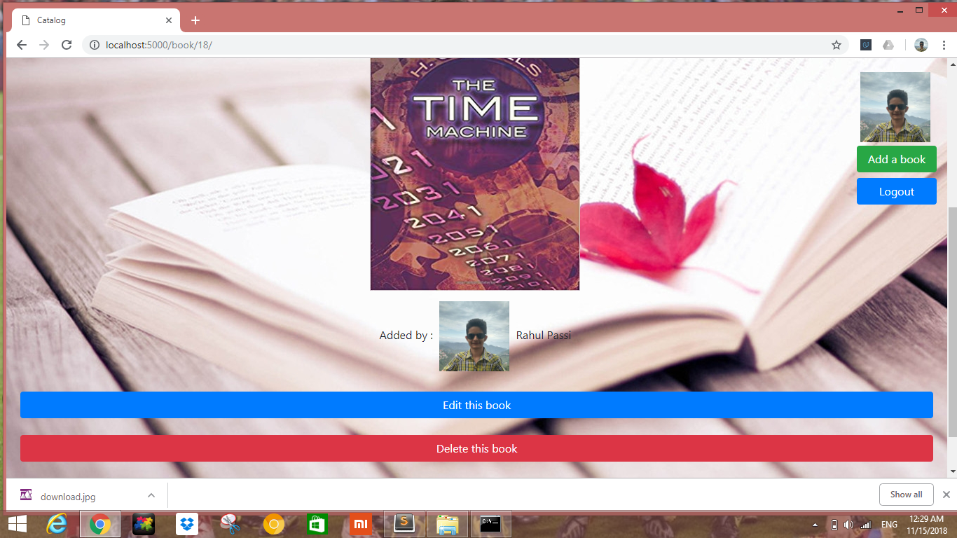

**Adding new book:**

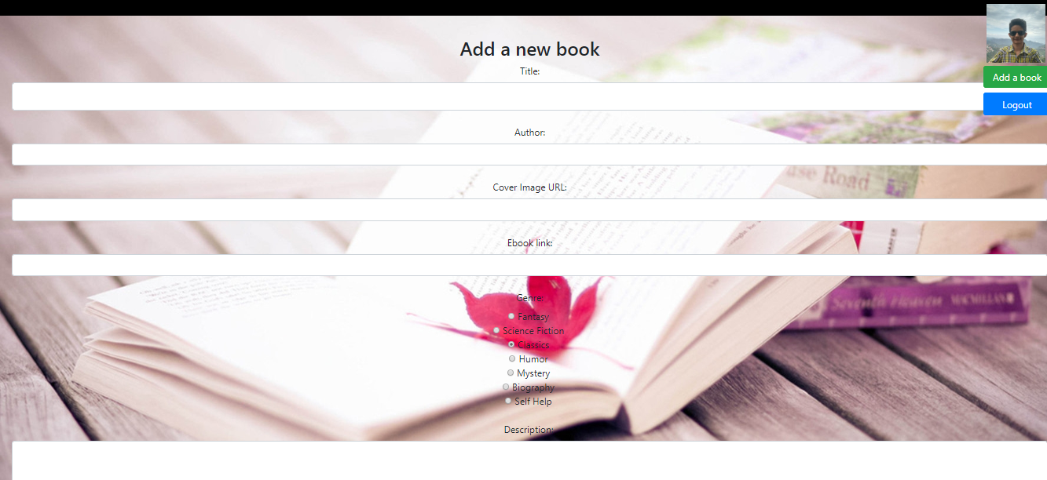

But the books created by other users are still not editable, nor can you delete them.

**For example: (different user)**

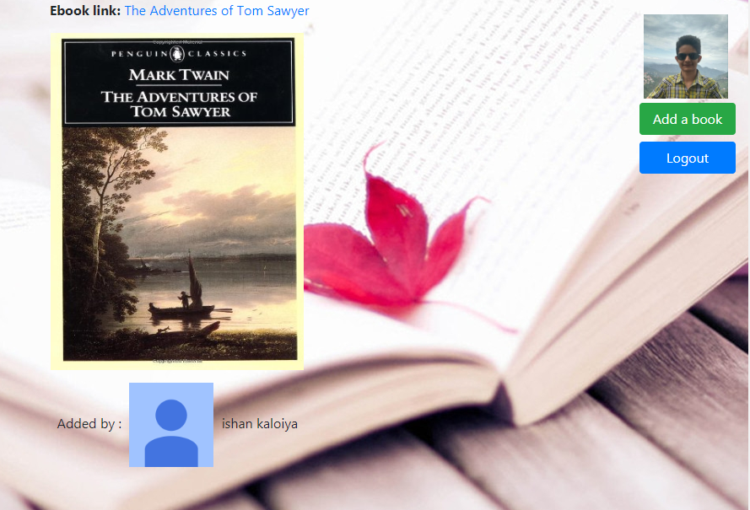

You can see above that no option to edit or delete book is there as the book was created by a different user.

Also as mentioned earlier, no one can edit or delete books of admin.

**Example of admin’s book:**

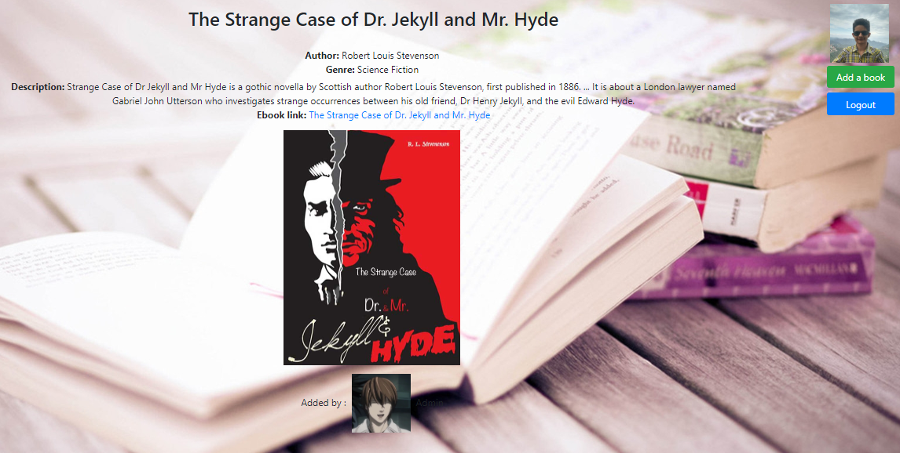

**Conclusion:**

* **Should allow access free of charge**

The content could be accessed via anyone to view the collection.

* **Should allow to add content**

One can include as many books as they like.

* **Should allow content security**

The uploaded content is unable to be removed by anyone except the uploader and admin.

* **Should have easy-to-find content**

The UI gives a detailed content information and gallery to choose from.

* **Should contain description of books**

The user will always know what kind of content they will be reading.

**Future Scope:**

The following section describes the work that will be implemented with future releases of the software.

•**Add more genres:**

More genres like criminal, psychological, kids would be added.

•**Add more books:**

More books for each existing genres will be added.

• **Enhance User Interface by adding more user interactive** **features:**

A search bar will be added to allow users to search for books.

•**Add favorite genres:**

Allow users to mark their favorite genres.

•**Add favorite books:**

Allow users to mark their favorite books.

•**Mobile application support:**

Both Android and IOS applications will be created to support it.

**References:**

<http://flask.pocoo.org/docs/1.0/>

<https://docs.python.org/2.7/>

<https://pip.pypa.io/en/stable/installing/>

<https://docs.sqlalchemy.org/en/latest/>

<https://developers.google.com/identity/protocols/OAuth2>

<https://www.sqlite.org/index.html>